Sprint 7 Status Report
For the Girl Scouts of America Badge Tracking
Application

By
Matt Eck
Michael Glosecki
Nathan Martz
Ryan Schroeder

Of
Team Cookie Council

1. The Council estimated 80 hours to complete sprint 7 however the sprint took us 65 hours. After the sprint was completed we had 15 hours left on the story tasks selected.

2. The focus of this sprint was to get the web pages ready for beta release mostly those pages that are essential to the tracking of badges and managing scouts in a troop.
- Journeys.php done by Ryan
- Query.php updated by Ryan
- UpdateBadgeRecords finished by Mike
- UpdateJourney.php done by Mike
- Scout Records started by Matt
- Add scout started by Matt
- myTroop started by Nate

3. Client’s suggested resource for server space called back and our needs for the server were discussed. He has yet to contact us back with any information.
4. Server risk was addressed but not mitigated.

Project Burndown chart
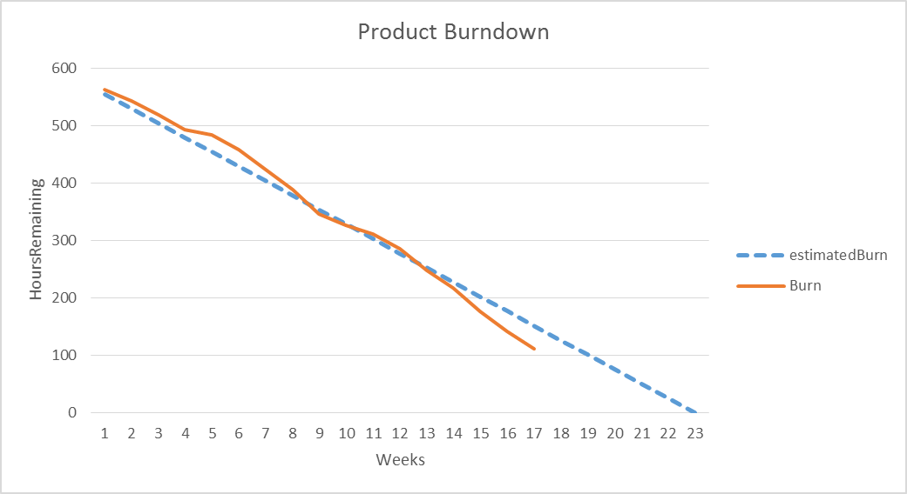

**Estimated total hours re-evaluated.

Sprint Burndown Chart
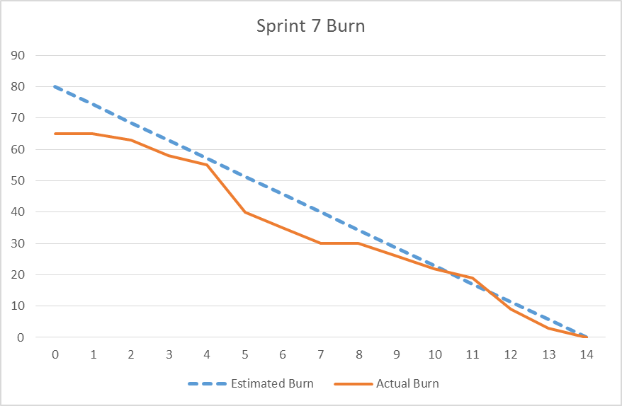

Weekly Development Effort
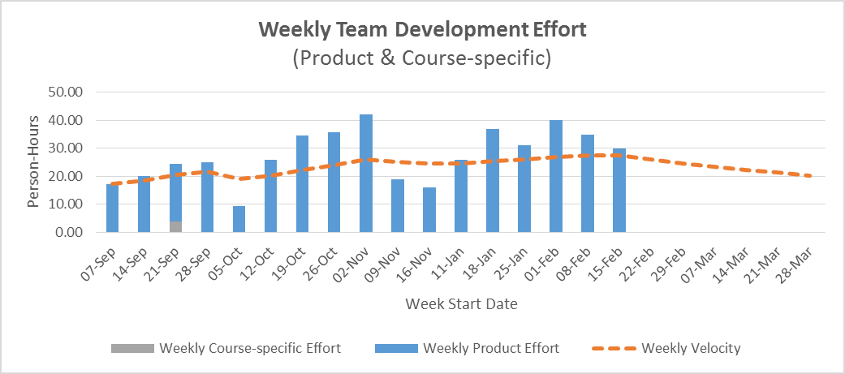

Daily Team Effort

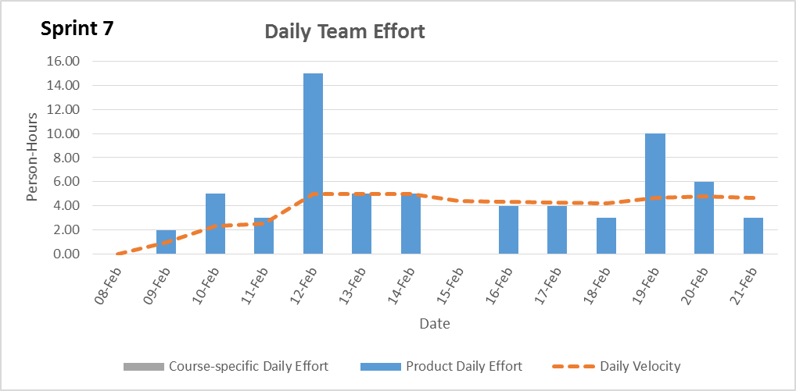

Team Member Effort
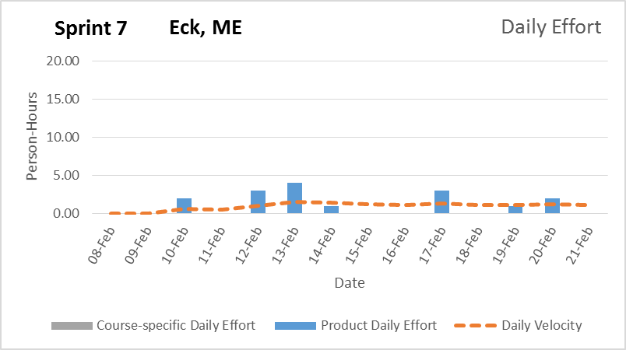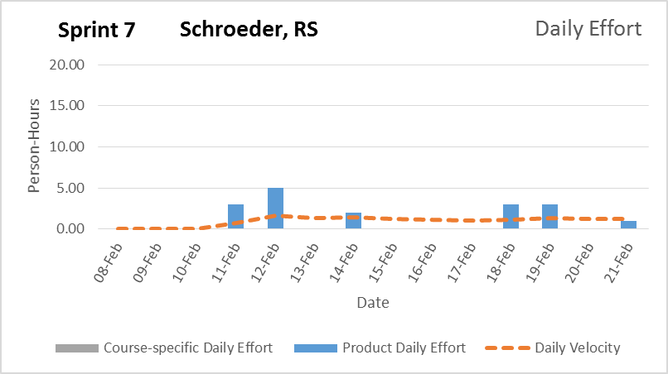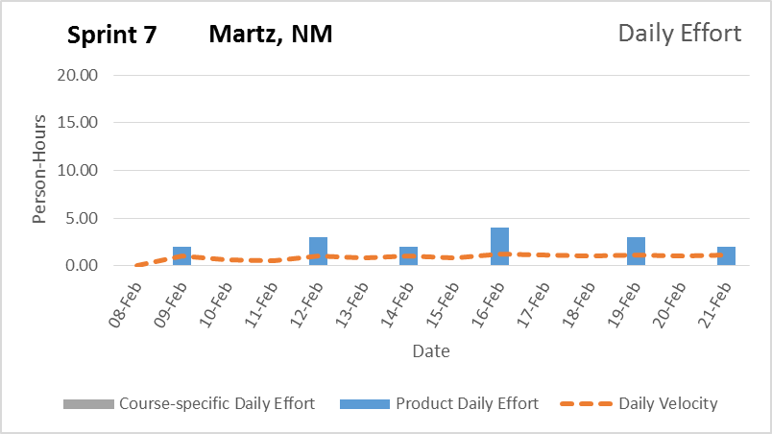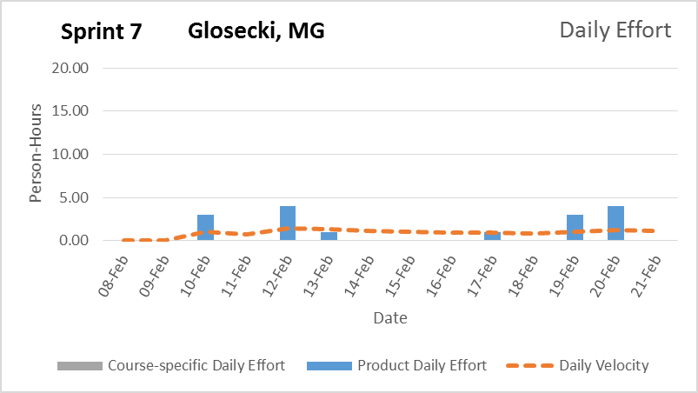

6. The team believes the browser version of this page will be complete with all functionality but the mobile app will be lacking in refinement.

Signature Date

__________________________________________ ______________

__________________________________________ ______________

__________________________________________ ______________

__________________________________________ ______________

